7.1.3 Sales Order Print

- You create Order Confirmation via this function.
- See below how use it.

Sales Order: fill sales order number as you can see below
CodeLang: 53 / us + Output: pdf + Next = OC will be sent to your mailbox

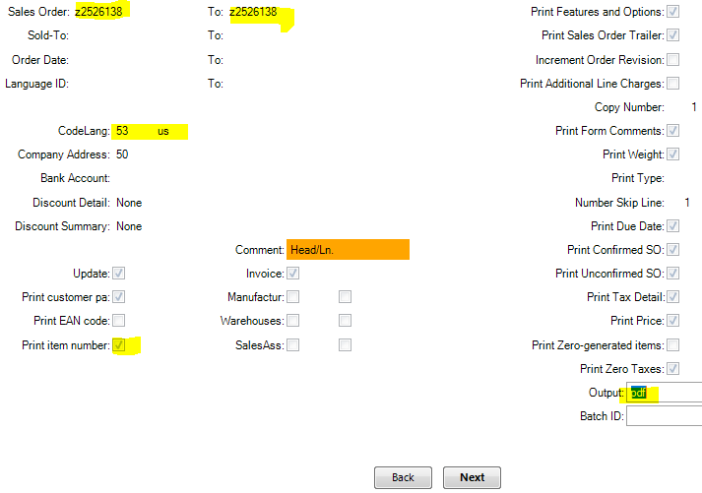

Check below information …..

Sales Order: fill sales order number as you can see below
CodeLang: 12 / us + Output: rolo + Next = OC will be displayed in QAD as a report

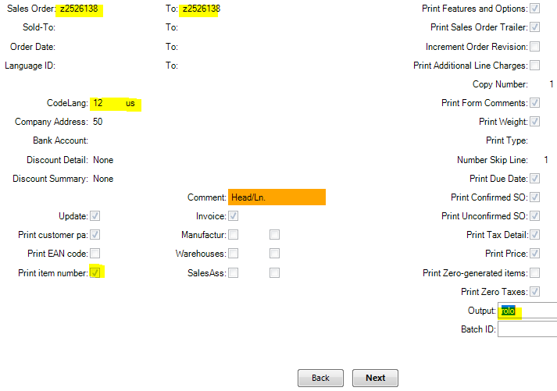

Check below information ….

This is how our Order Confirmation looks via rolo output.

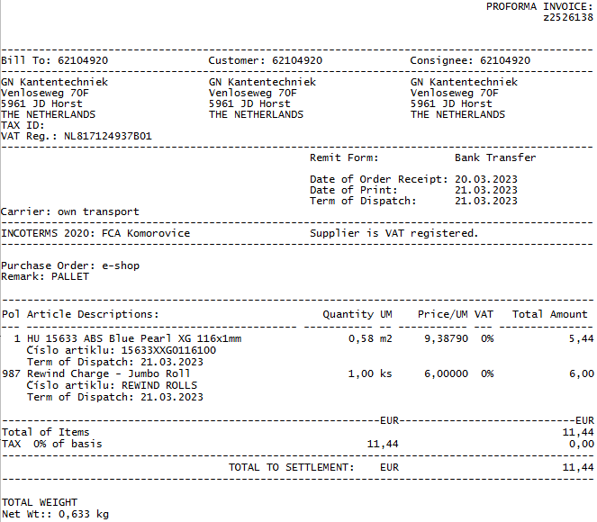

Check below information ….

You also can create Order Confirmation via function 51.2.2.22 Sales order lines – assistents
Right click on Sales Order number

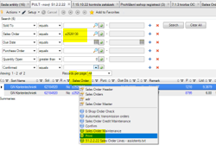

Sales Order: is copyied automatically
Code Lang: is set automatically
Print item number: just click the filed if you need/want our full article name to be appeared on the OC.
+ Next

